PL/SQL OUTPUTS

Name : G. Sri Ratna Hemanth

Superset id : 6124988

1. Control Structures

**Step – 1 :** Create customers and loans tables and insert values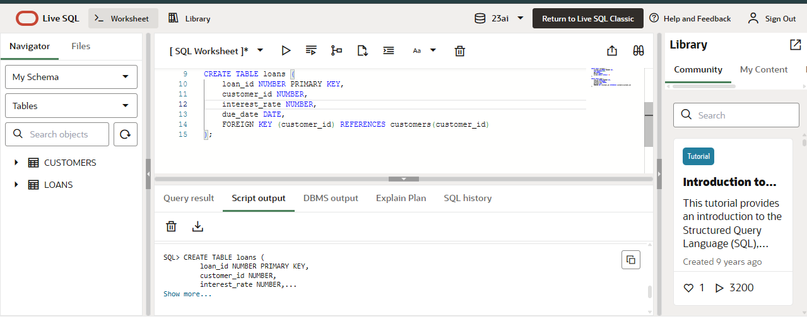

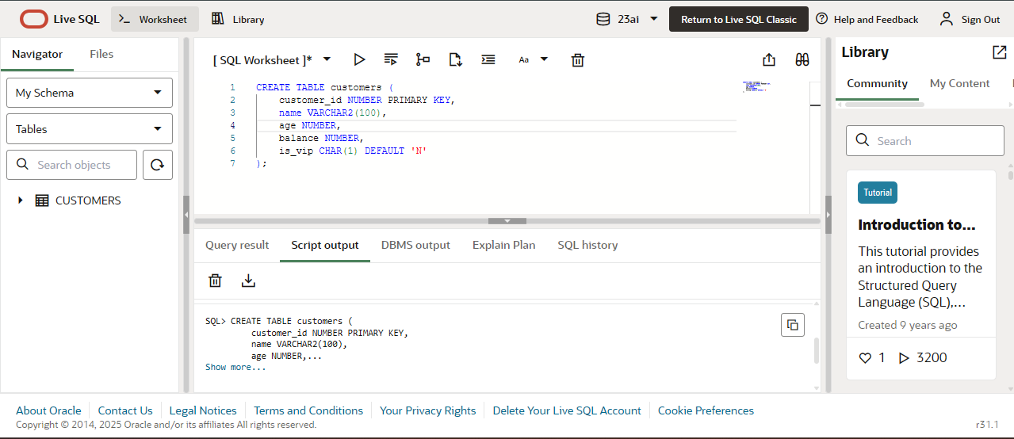

**Step – 2 :** Create a PL/SQL block that loops through all customers, checks their age, and if they are above 60, apply a 1% discount to their current loan interest rates.

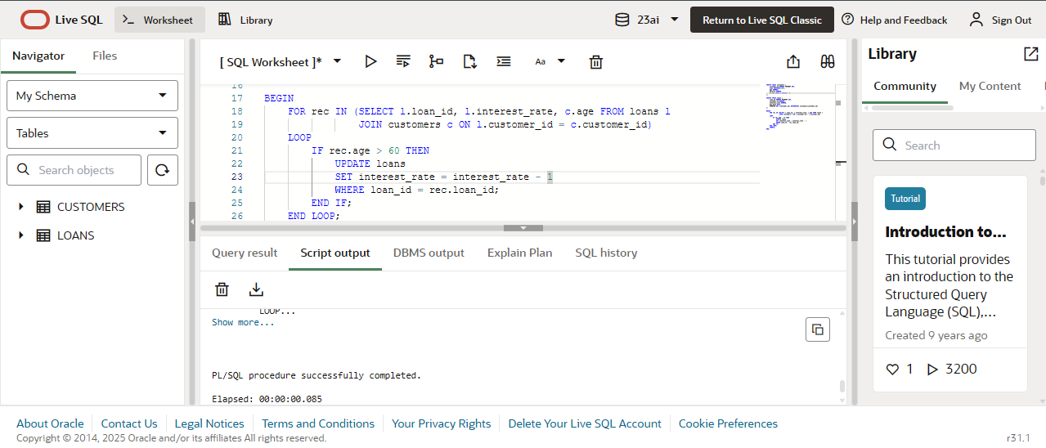

**Step – 3 :** Create a PL/SQL block that iterates through all customers and sets a flag IsVIP to TRUE for those with a balance over $10,000.

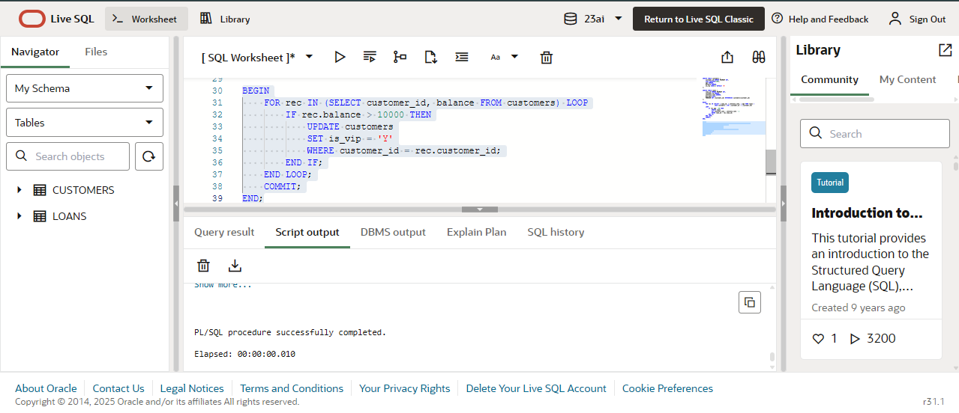

**Step – 4 :** Create a PL/SQL block that fetches all loans due in the next 30 days and prints a reminder message for each customer.

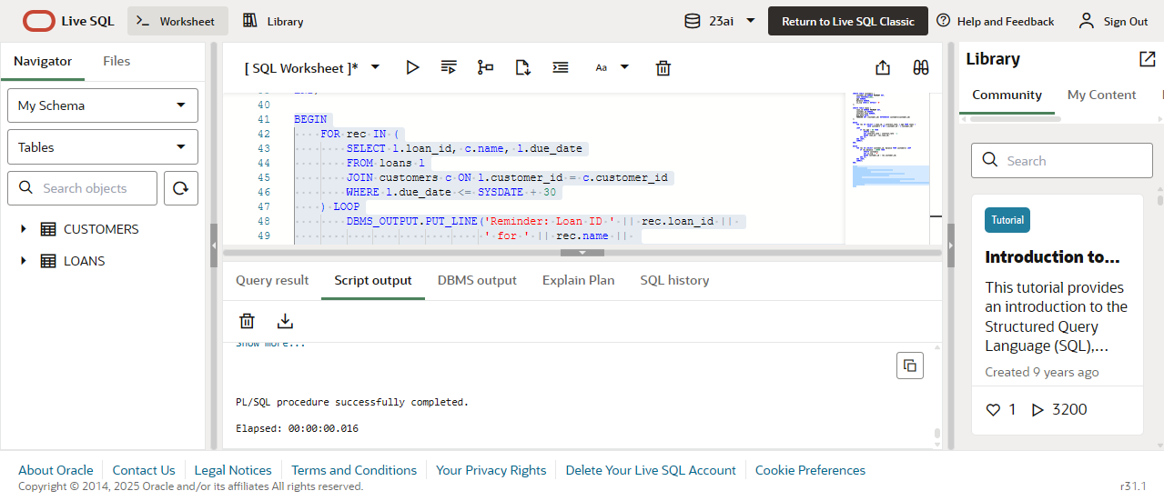

**Output :** Check the output in DBMS output

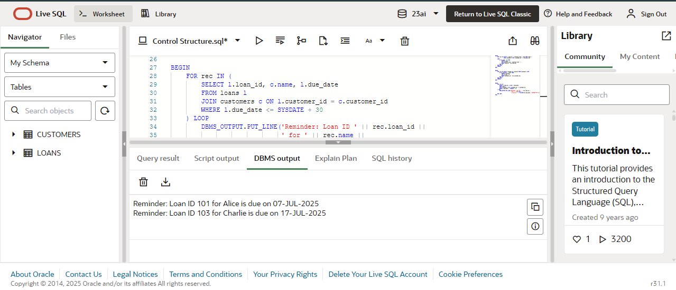

1. Stored Procedures

**Step – 1 :** Create a table named accounts and employees and insert values in them.

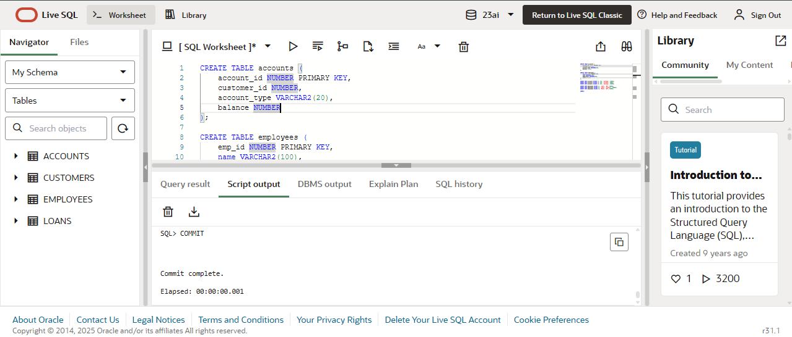

**Step – 2 :** Process Monthly Interest

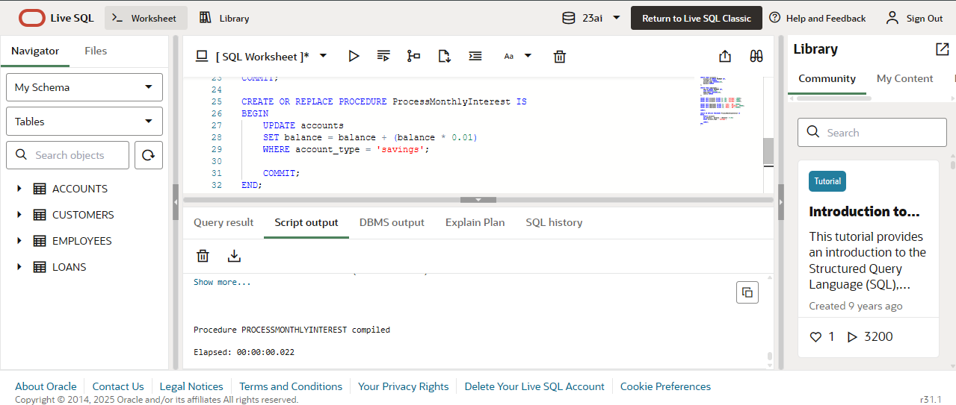

**Step – 3 :** Update Employee Bonus

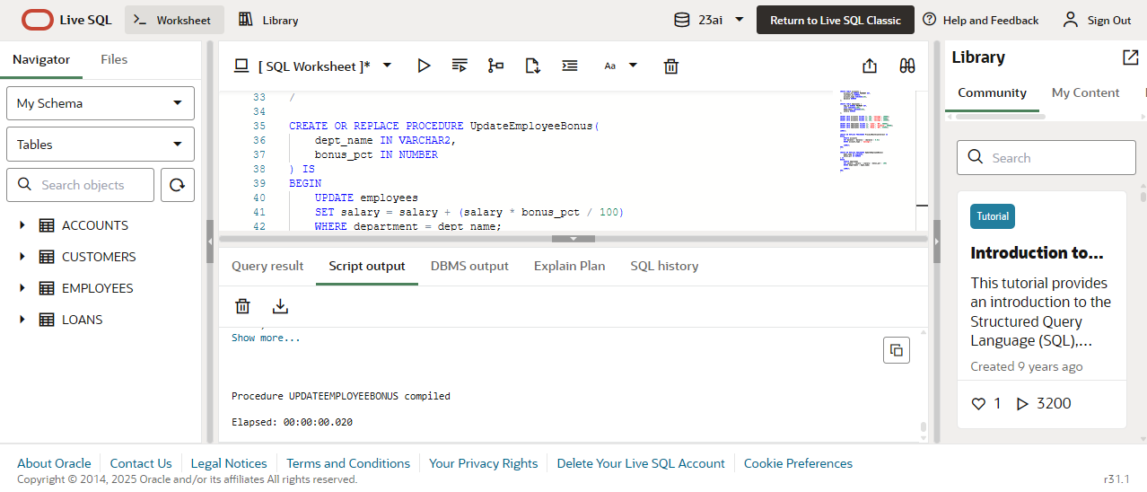

**Step – 4 :** Transfer Funds

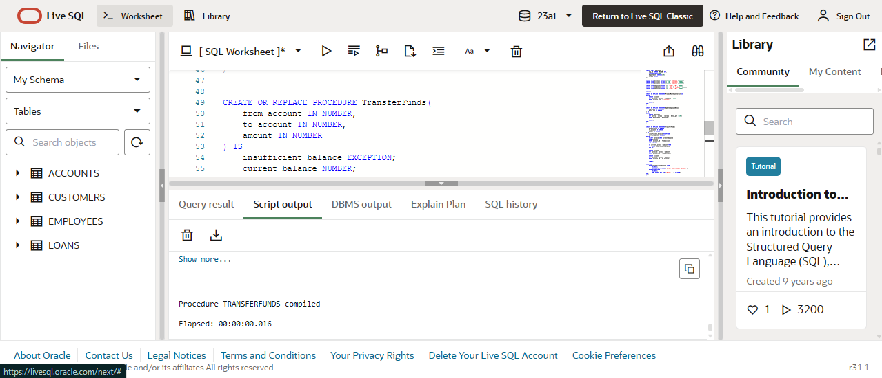

**Step – 5** **:** Test the methods.

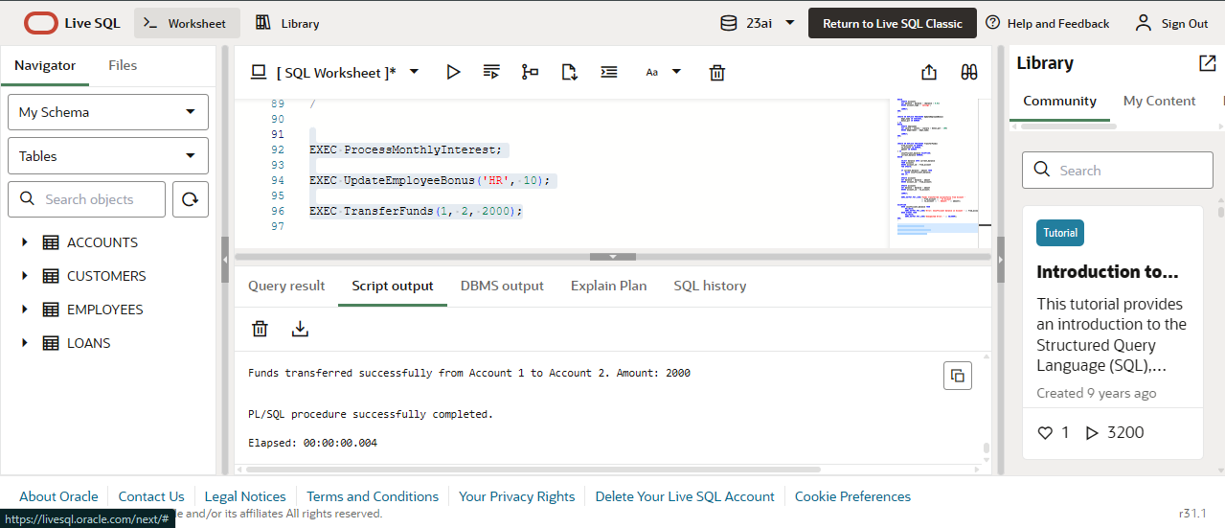

OUTPUT :

See the balance of account 1 and account 2

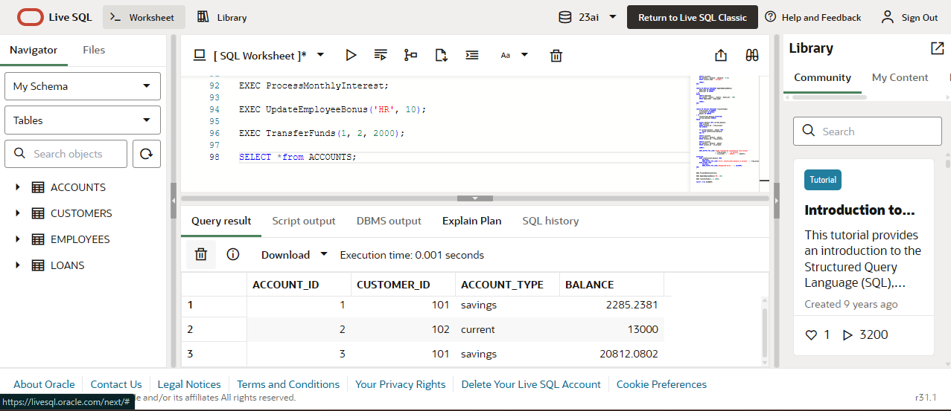

Now I am transferring 2000 from account 1 to account 2.

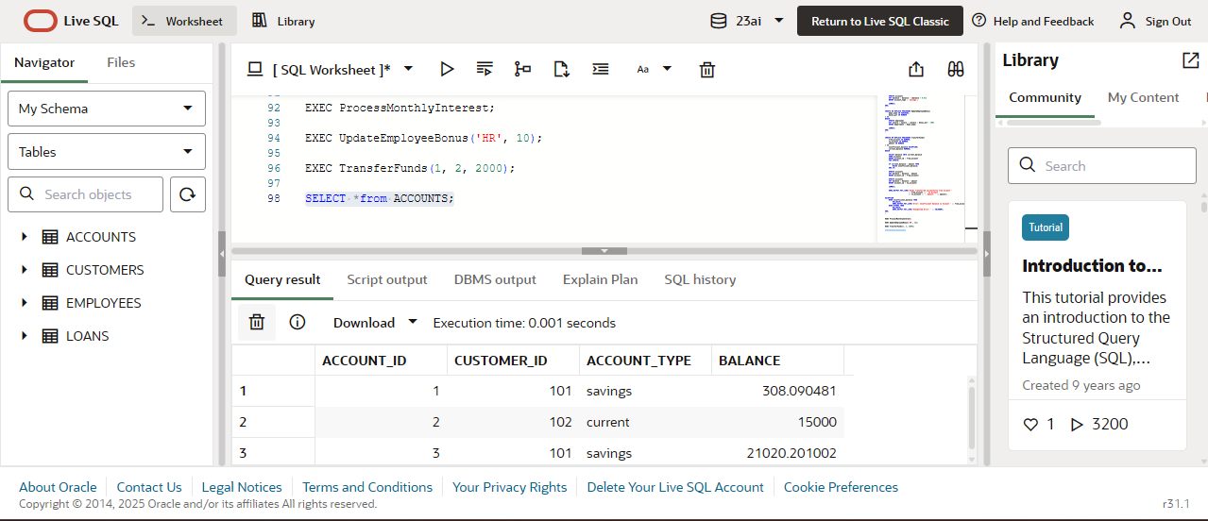

Look at the difference in balance.